**Project Structure**

**Database Logic Layer:**

**JobDashBoard.IDAL – repository interface**

JobDashBoard.DAL - repository layer, use EF code-first to generate database and datas

**Business Logic Layer**

**JobDashBoard.IBLL** – service interface

**JobDashBoard.BLL** – service implement

**Web API Layer**

Use Ninject to implement dependency injection

The method GetWorkHours in SearchApiController return json data for front end to use

Eg:

Visit <http://localhost:34083/api/SearchApi/GetWorkHours/2019-09-19/2019-09-24>

Will get json result :

[

{   
      **"StaffNo"**:1004,  
      **"FirstName"**:"Ben",  
      **"LastName"**:"Paose",  
      **"BeginDate"**:"2019-09-19T00:00:00",  
      **"EndDate"**:"2019-09-24T00:00:00",  
      **"WorkHours"**:7.5  
   },  
   {   
      **"StaffNo"**:1005,  
      **"FirstName"**:"Nino",  
      **"LastName"**:"Norman",  
      **"BeginDate"**:"2019-09-19T00:00:00",  
      **"EndDate"**:"2019-09-24T00:00:00",  
      **"WorkHours"**:8.0  
   },  
   {   
      **"StaffNo"**:1003,  
      **"FirstName"**:"Pant",  
      **"LastName"**:"Vini",  
      **"BeginDate"**:"2019-09-19T00:00:00",  
      **"EndDate"**:"2019-09-24T00:00:00",  
      **"WorkHours"**:5.5  
   },  
   {   
      **"StaffNo"**:1001,  
      **"FirstName"**:"Kim",  
      **"LastName"**:"Andrew",  
      **"BeginDate"**:"2019-09-19T00:00:00",  
      **"EndDate"**:"2019-09-24T00:00:00",  
      **"WorkHours"**:10.0  
   },  
   {   
      **"StaffNo"**:1002,  
      **"FirstName"**:"Hua",  
      **"LastName"**:"Li",  
      **"BeginDate"**:"2019-09-19T00:00:00",  
      **"EndDate"**:"2019-09-24T00:00:00",  
      **"WorkHours"**:9.5  
   }  
]

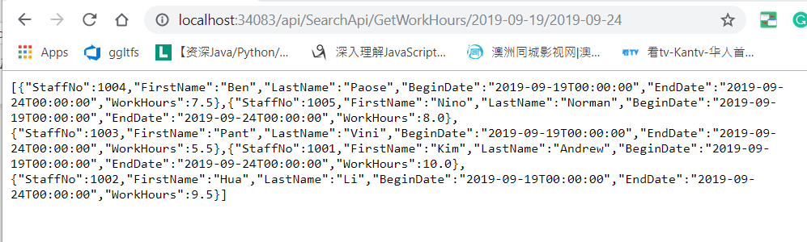

The JSON Result show the staffs and their work hours between 2019-09-19 and 2019-09-24